Experiment No.05
Title: Throughput and latency measurement using network tools (e.g., ping, speed test).

Aim: To measure the latency (Round Trip Time) and throughput (upload and download speed) of a network connection using standard network tools such as Ping and Speed Test, and to analyze the obtained results.
Requirement:

Hardware
- Wi-Fi Router
- Laptop with Wi-Fi adapter
Software
- Python 3.x
- Jupyter Notebook / Google Colab / VS Code
- Libraries:
  - matplotlib
  - numpy

Theory :

Throughput
Throughput is the actual amount of data successfully transferred over a network per unit time.
It is usually measured in:
- kbps (Kilobits per second)
- Mbps (Megabits per second)
- Gbps (Gigabits per second)
Higher throughput indicates better network performance.

Latency
Latency is the time taken for a data packet to travel from the sender to the receiver and back.
It is also called Round Trip Time (RTT).
Unit:
- milliseconds (ms)
Lower latency indicates faster network communication.

Procedure

Latency Measurement Using Ping

Step 1
Connect the computer to the Internet.

Step 2
Open Command Prompt (Windows) or Terminal (Linux).

Step 3
Execute the following command:
Windows
ping google.com
Linux
ping -c 10 google.com

Step 4
Observe:
- Reply time
- Average RTT
- Packet loss

Throughput Measurement Using Speed Test)

Step 1
Open a web browser.

Step 2
Visit a speed test website.

Step 3
Click Go or Start.

Step 4
Wait until the test completes.

Step 5
Record:
- Download Speed
- Upload Speed
- Ping
- Jitter (if available)

Python Code

Python Program for Plotting Results

import matplotlib.pyplot as plt

# Sample data

parameters = ['Download', 'Upload', 'Latency']

values = [95, 42, 18]

plt.figure(figsize=(7,5))

plt.bar(parameters, values)

plt.title("Network Performance")

plt.ylabel("Value (Mbps / ms)")

plt.grid(axis='y')

plt.show()

Observation
- Ping command measures the Round Trip Time (RTT).
- Lower latency indicates a more responsive network.
- Download throughput is usually higher than upload throughput in broadband connections.
- Stable networks have low jitter and negligible packet loss.

Output

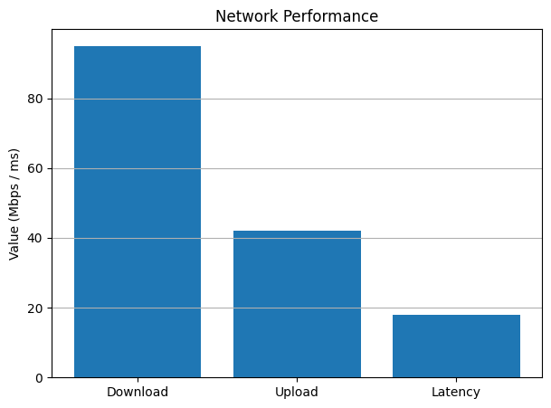

Applications
- Internet Service Provider (ISP) performance evaluation
- Wi-Fi network optimization
- Network troubleshooting
- Quality of Service (QoS) analysis
- Video conferencing performance testing
- Cloud computing connectivity assessment
- Online gaming network analysis
- Enterprise network monitoring
Conclusion:
The experiment successfully measured the latency and throughput of the network using Ping and Speed Test tools. The measured values indicate the overall performance of the network and help evaluate its suitability for applications such as web browsing, video streaming, online gaming, and video conferencing.

